Perfect Numbers
Platform: LeetCode
Language: C
Module 5, Question 6

Problem Link
https://leetcode.com/problems/perfect-number/description/

Problem Statement
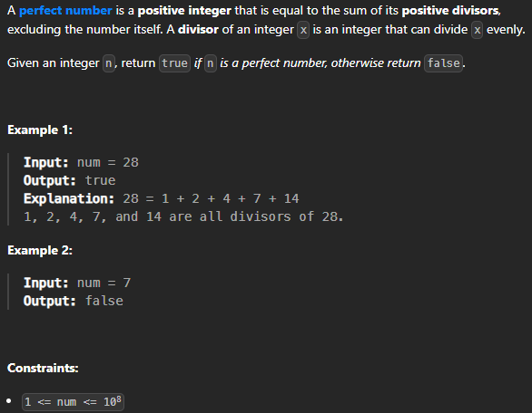

C Code
bool checkPerfectNumber(int num) {
if (num <= 1) return false;

int sum = 1; // 1 is a divisor of every number
for (int i = 2; i * i <= num; i++) {
if (num % i == 0) {
sum += i;
if (i != num / i)
sum += num / i; // add the paired divisor
}
}
return sum == num;
}

Screenshot of Successful Submission



